Student Activity Committee & Sportswear Order Form 2025–26

Committee Clothing:
- All committee clothing is charcoal in colour.
- Items are available in sizes XS to 2XL. For other sized, contact Callum Bell before ordering.
- Choose from 3 options:
  - A: Item with Students’ Union & University of Aberdeen crests on the chest.
  - B: Option A plus Student Activity name on back.
  - C: Option B plus your name and committee position on sleeve.
- Samples available at the Students’ Union Sports Office for size checks.

Clothing & Pricing

Committee Hoodie  Option A - £24.75  Option B - £29.25  Option C - £34 | Committee ¼ zip Hoodie  Option A - £28.50  Option B - £33.25  Option C - £38.00 | Committee sweatshirt  Option A - £23.25  Option B - £28.25  Option C - £32.25 | Committee tee  Option A - £13.75  Option B - £18.50  Option C - £23.00
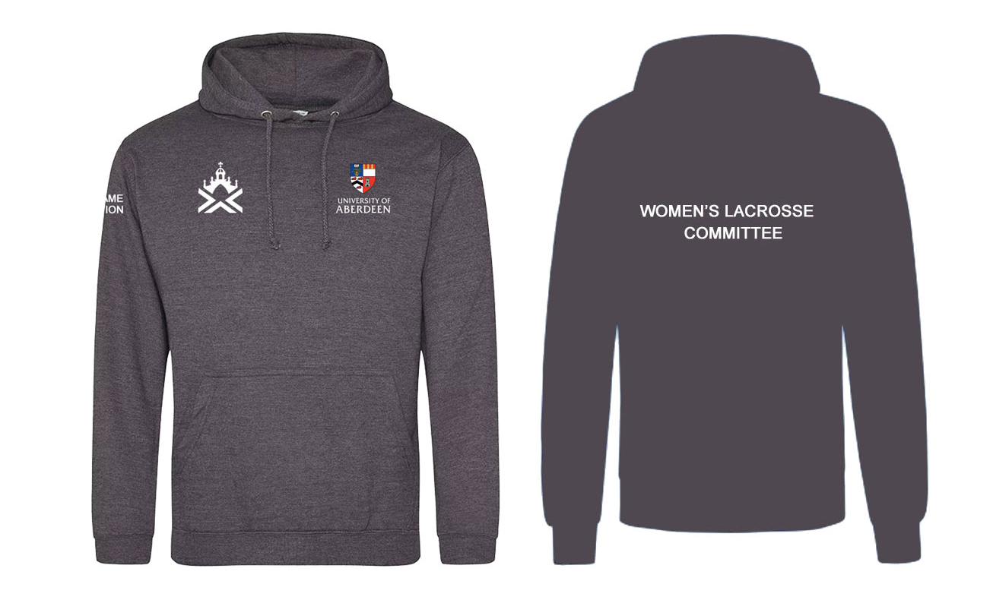 | 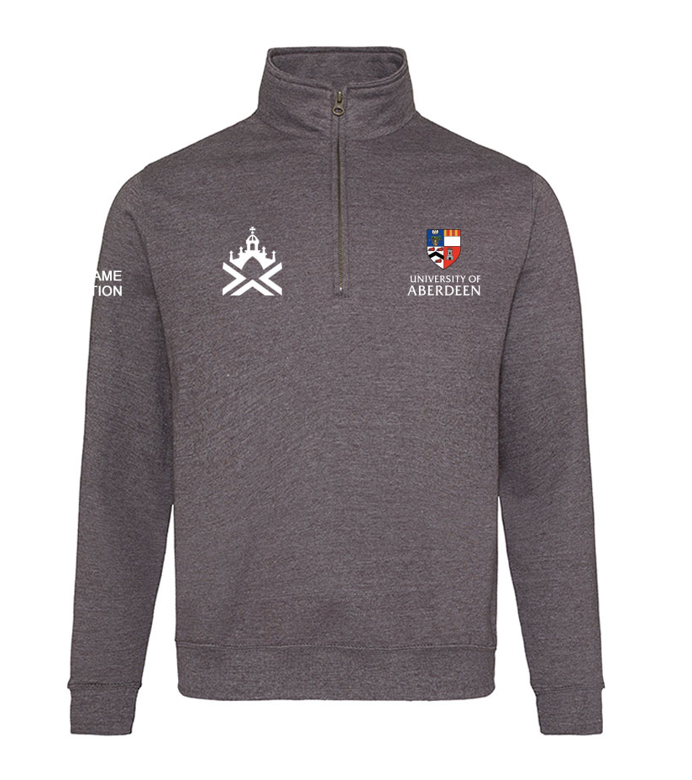 | 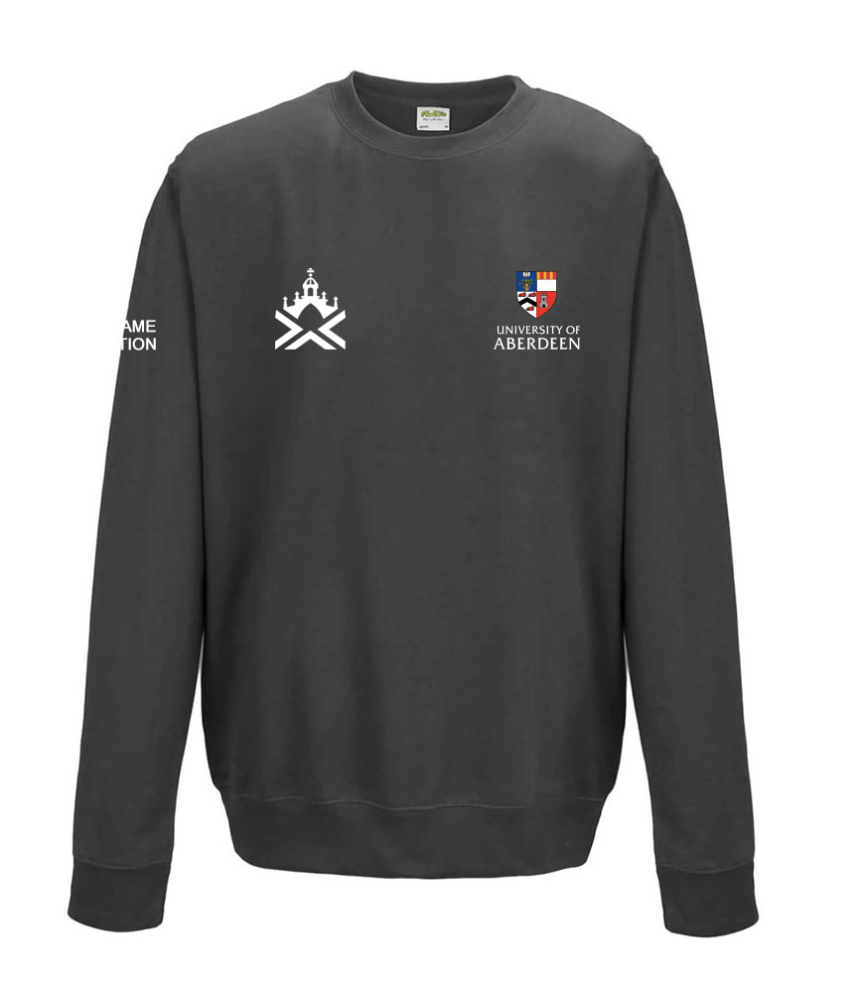 | 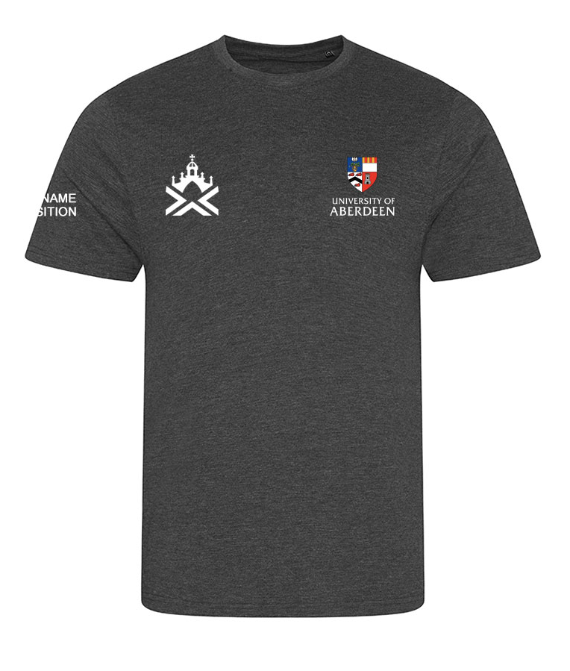

Sportswear:
- Main kit colours - royal blue and gold. Away kits - red or white
- Includes University of Aberdeen and brand logos on the chest.
- Full range available on the PSL Website. Can’t find something contact Callum Bell
- Some samples available at the Students’ Union Sports Office for size checks.

Ordering and Payment:
- Complete this form and email to Callum Bell, c.c., Students’ Union Sports Office
- For sports kit, you may also order directly via the PSL Website (delivery will take longer).
- Invoice will be sent from Stevensons to your @AUSA email (Lauren St. John)
  - Full payment is required before production of your items start.
  - For support using the Student Group Finance system, please see here.

Delivery Information:
- Orders will be delivered to Students’ Union Sports Office, ASV, Linksfield Rd, Abdn, AB24 5RU.
  - You will receive a DPD dispatch notification from PSL. The Sports Office will contact you when items arrive ready for collection.
- Delivery during peak times (July-Sept) may take longer:
  - XXV Stock approx.: 3 weeks
  - Sublimated/New Kit approx.: 5 weeks:
  - Canterbury Stock approx.: 3 weeks

Contact Details
Contact Name
Committee Position
Student Activity
(will be used for Style Option* B)
Student Activity @AUSA Email address
Product Type  (i.e., Committee ¼ zip hoody or Mens Multi-sport jersey) | Committee Clothing  Style Option*  A, B, C | Committee Clothing  Name & Position for sleeve  (Style Option C Only) | Size | Cost
Please double-check that the information below is accurate, as changes may not be possible
 |  |  |  | £
 |  |  |  | £
 |  |  |  | £
 |  |  |  | £
 |  |  |  | £
 |  |  |  | £
 |  |  |  | £
 |  |  |  | £
 |  |  |  | £
 |  |  |  | £
 |  |  |  | £
 |  |  |  | £
 |  |  |  | £
 |  |  |  | £
 |  |  |  | £
 |  |  |  | £
TOTAL TO BE PAID |  |  | £

CONTINUED.
Product Type  (i.e., Committee ¼ zip hoody or Mens Multi-sport jersey) | Committee Clothing  Style Option*  A, B, C | Committee Clothing  Name & Position for sleeve  (Style Option C Only) | Size | Cost
Please double-check that the information below is accurate, as changes may not be possible
 |  |  |  | £
 |  |  |  | £
 |  |  |  | £
 |  |  |  | £
 |  |  |  | £
 |  |  |  | £
 |  |  |  | £
 |  |  |  | £
 |  |  |  | £
 |  |  |  | £
 |  |  |  | £
 |  |  |  | £
 |  |  |  | £
 |  |  |  | £
 |  |  |  | £
 |  |  |  | £
 |  |  |  | £
 |  |  |  | £
TOTAL TO BE PAID |  |  | £

